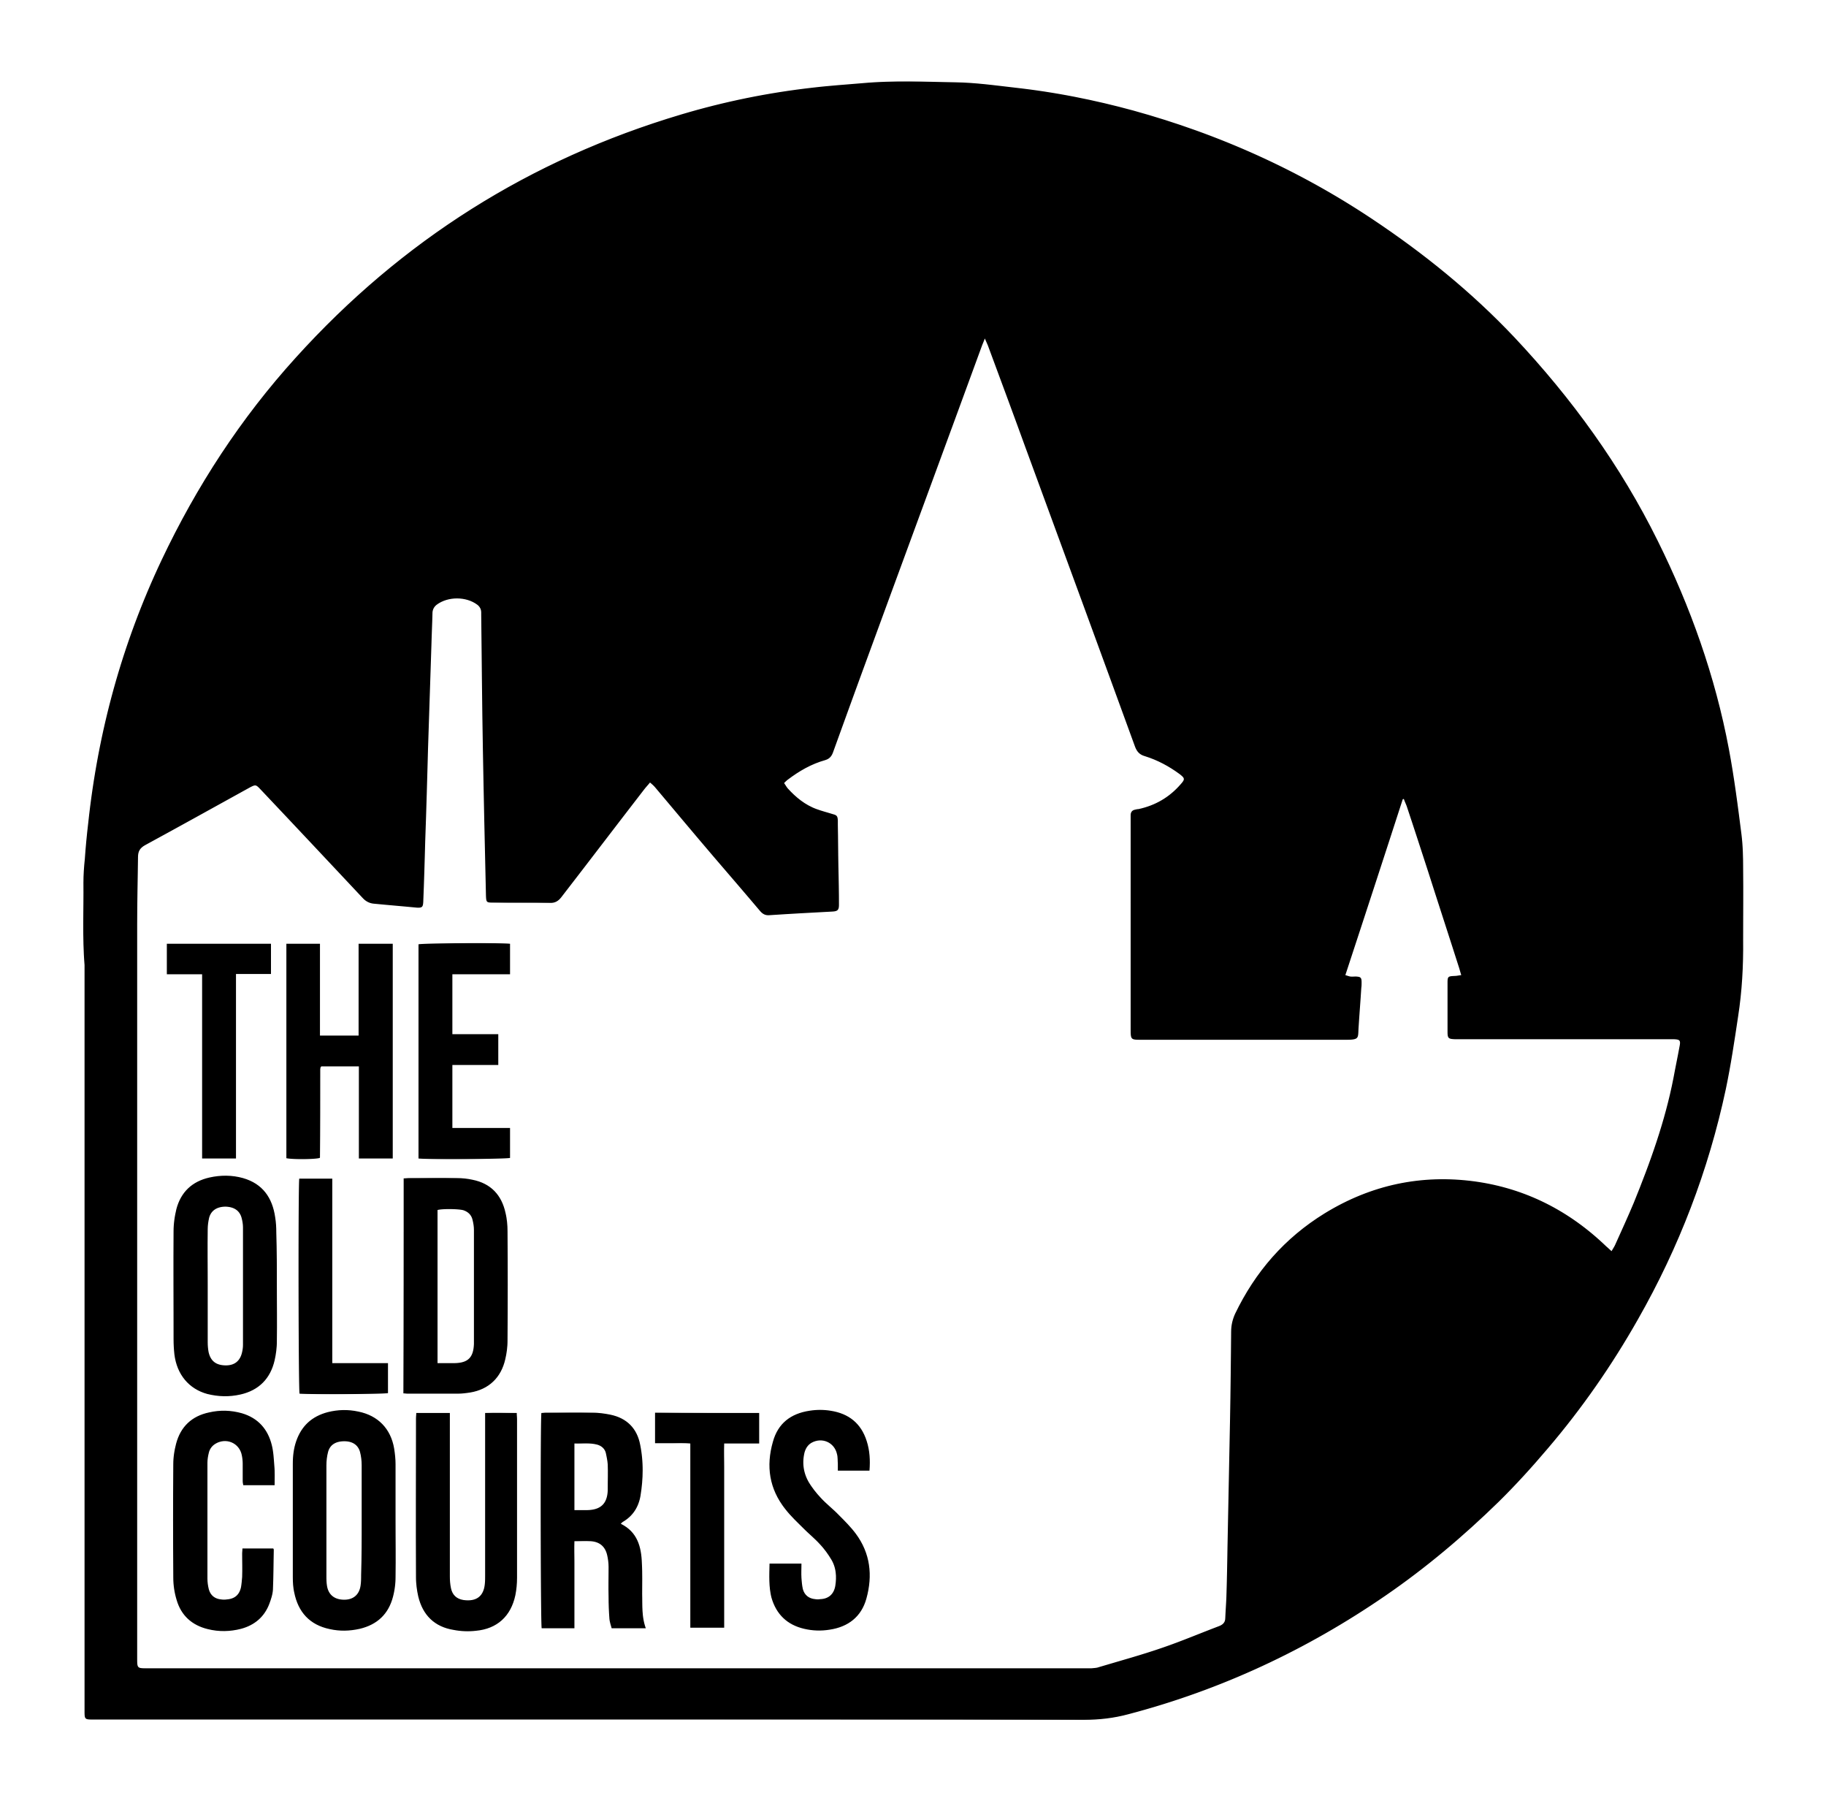

Projects Officer
Applicant Information Pack

Contents
Introduction / How to Apply 2
About the Old Courts 3
Our Artistic Vision 3
What we do 4
Working at the Old Courts 5
The Role 6
Terms & Conditions 8

23/11/2021

Introduction / How to Apply

Thank you for your interest in the role of Projects Officer at Arts at the Mill CIC T/A The Old Courts. You will find information about the role and the person specification in the following pages. Before apply, please read the information included here.

Please use the online application form to apply. A link to the online application form can be found on the Jobs page of our website. You will need to upload your CV and a covering letter as part of the application.

All applications must be submitted by Midday on Monday 20 December. Successful shortlisted applicants will be invited to attend an interview on Monday 10 or Tuesday 11 January 2022. We can provide a BSL interpreter if required.

If you would like further information, support with access requirements or an informal chat about the post please contact us by email at rosies@theoldcourts.com

We look forward to receiving your application.

People Team
Arts at the Mill CIC

About the Old Courts
The Old Courts is all about changing perceptions. Our mission is to create, engage and inspire by supporting ideas and hard work, providing cultural opportunities, and investing in Wigan and its people.

Wigan is a place where world-class culture thrives.

Our Artistic Vision
We understand the incredible importance of the arts – not simply for entertainment, but as the fundamental threads in the fabric of everyday life.
The arts should not be exclusive to the well-travelled nor a social tool for privileged circles. The arts are what bond communities and bridge differences with the only true global language, expression.
At The Old Courts, our work is designed to introduce the arts into the lives of the people of Wigan and beyond and to enhance the experience of those who are engaged.
We are driven to CREATE a vibrant, supportive, risk-taking and strategic environment for artists to ENGAGE new and existing audiences and disconnected communities who we will help to INSPIRE change with unrivalled ambition.

What we do
Artist Development

We are fully committed to using our resource as a tool to further the progress of artists. Since first opening our doors we have played a part in the development of artists in many different ways. We have encountered raw talent from individuals seeking opportunity with little or no knowledge of how to find it and we have been approached by established performers who required support in networking or bid-writing. Whatever the ask, whatever the experience and whatever the artist is trying to achieve, we take pride in our ability to unlock potential and play a key role in development. The future of the arts is being forged as we speak. For arts and culture to play an increasingly important role in everyday life, time, experience, knowledge and dedication will always be needed from organisations like ours and we will continue to provide it.

Producing

We have a strong track-record in producing work for artists. A combination of in-house talent, facility and our wider network across The UK allows us to develop embryonic projects into touring, sustainable work. We understand the distance that can exist between a brilliant script and the stage but our ability to aid and structure the research, development and production of work allows work to be made entirely on site.

Community Work

Our surroundings play a fundamental role in everything we do. We are very proud to be from Wigan and based in Wigan and we appreciate how our organisation has been embraced by those who we live and work amongst. As such, we get great satisfaction from the many community projects we run. We have a community programme filled with meet-ups, social opportunities, upskilling, entertainment and more. The Old Courts is a place where anyone is welcome and it is fair to say that what we do is of significant value to a host of local groups and individuals

Co-Creation

We are developing several co-created projects which will bring artists to Wigan to make work with talent from our borough. One such project is ‘Moving Roots’ which involves theatre producers from partner organisations from around The UK, including London, Cardiff and Peterborough. As a member of this consortium and working with a theatre maker from Manchester, we recently created ‘Rent Party’, a show right here in Wigan created with local talent to provide a platform for both performers in the town and the culture of the town itself.

Live Events

Since day one, a significant part of what we do centres around live events. Gigs, dance shows, theatre shows, exhibitions, film screenings, sector conferences, audience events and seminars provide artists and the public with the maximum number of entry points to the arts.

Working at the Old Courts

The Old Courts main office space is based inside the Former County Court offices on Crawford Street, in Wigan Town Centre. We have a vibrant mix of individual offices and open plan co-working space with a selection of accessible meeting spaces.
The role will involve regular meetings, communicating via phone/video, email and in person and using a computer for several hours across the day. Some evening and weekend working may be required as part of this role, and some national travel to visit project partners across the country. Attending performances, events and being part of the creative life of the organisation is part of everyone’s role at the Old Courts.
The Old Courts is a busy organisation and has around 60 members of staff. Usual office hours are 10am-6pm and we offer flexible working where possible. We welcome discussing flexibility at interview.

The Role
Responsible to: Project Director
Responsible for: No line management responsibilities
Main Roles and Responsibilities include the below and carrying out any additional responsibilities as required by your line manager or by the leadership team of Arts at the Mill CIC.

The Projects Officer will play both a leading and supportive role across a range of projects led by The Old Courts.
The central activity that the Projects Officer will support is the Collaborative Touring Network (CTN). The Collaborative Touring Network is a growing national collective of arts organisations, working in areas of low cultural engagement to provide access to the arts for everyone. Led by The Old Courts, this network believes every town deserves perspective-changing live performance, and we work with artists and communities to make this possible in our places.
Internally, the Projects Officer will oversee this and other projects, and work with multiple departments to ensure activity is completed on time and to budget. Externally, you will work with partners locally and nationally (for example: cultural, heritage & community organisations, artists, Local Authority) to develop and deliver projects in ways that are collaborative and supportive. Day to day, the work is a rich balance of managing relationships, overseeing live projects, developing future projects, and when required, supporting the wider Development team to apply for funding to resource such projects.
The Projects Officer role will suit an excellent communicator who would describe themselves as a completer/finisher with an eye for detail. Whilst we always welcome an interest in the arts, we are also interested in hearing from people who bring project management experience from other sectors.
We welcome someone bringing fresh energy, insight, and new skills & experience into our workplace. We are actively seeking diversity of experience, and whoever you are, we would love to hear from you! We would love to receive applications from people who identify as working class, LGBTQIA+, deaf or disabled, care-experienced, young carers, young people of South, East and South East Asian heritage, African or Caribbean heritage, Gypsy, Roma or Irish Traveller heritage or Latinx heritage.

Outlined below are several standard duties that this job role entails:

Support large national and local Projects, with a focus on the Collaborative Touring Network
- Work as a member of a project team on large projects, where the project lead is the Project Director or a Director, playing a supportive role to ensure that the project objectives and success criteria are met, and the project is delivered on time & to budget
- Support project leads to plan and coordinate projects and to organise project teams
- Use our systems to track & update on the progress of live projects. Work with the Project Director, freelance evaluators, and the wider Development Team to establish what success looks like per project and ensure this is measured
- To update and manage project risk registers
- Monitor project spend and work with the project leads to reallocate resources to meet the evolving needs of the project
- Lead on planning both consortium and internal meetings for projects; arranging agendas, logistics, guests, and access provisions incl. recording and streaming where appropriate
- Lead the process of contracting freelance project contributors, including artists
- Lead on the logistical planning and delivery of national touring activity, including managing the provision of travel and accommodation across touring personnel
- To oversee the administration of artist call-out, application and commissioning processes
- To travel to partner locations in England during key moments each year, alongside the Project Director. To provide on the ground troubleshooting and project management support during these visits.

External engagement
- Contribute to the development of high-quality content for publication externally on our website, blog, media platforms that raises the profile of projects & enhances the reputation of Arts At The Mill CIC with target audiences and stakeholders
- Support the Project Director and/or Directors with the development of external facing documents and presentation about our organisations and projects when necessary
- Contribute towards bi-monthly and annual reports

- Support Centralised Project Management
- Contribute to the development of new centralised systems for project management across the organisations’ multi-site offer, to ensure we deliver effectively
- To work closely with a fellow Projects Officer and the wider Development team, sharing regular updates across the team
- To adopt and enhance effective project management, building on existing systems and developing new ones as appropriate.

Person Specification

Skills & Abilities | Desirable | Essential
Project management experience |  | X
Able to maintain effective working relationships with a wide variety of people and organisations |  | X
Strong written and verbal communication skills |  | X
Attention to detail |  | X
Understanding and commitment to equal opportunities and an ability to relate to people across the community |  | X
Good IT skills with a good working knowledge of Microsoft Office Word and Excel, and ability to learn new project management software |  | X
Self-motivated and able to work unsupervised with good administration, organisational, and time management skills |  | X
Ability to multitask - leading and/or contributing to multiple projects at once |  | X
Ability to work flexibility, creatively and outside your usual area of expertise |  | X
Experienced in facilitating project working amongst organisations artists and/or local authority | X
Experience of working with arts, culture & heritage organisation and the public or voluntary sectors | X
Proven ability to successfully manage the delivery of projects to time and budget | X
Ability to produce attractive and professional looking outputs using the likes of Canva, Google Slide | X
Ability to think strategically and contribute to future planning | X
Values
Concern for social issues and an understanding of the organisation’s mission | X
Happy to take on new challenges |  | X
A keen learner who invests time and effort into their own development |  | X

Terms & Conditions
Salary: £24,000 gross per annum, depending on experience
Hours: 37.5 hours per week, excluding a daily one-hour lunch break.

This role is 5 days a week Monday-Friday; usual office hours are 10am-6pm. We offer flexible working where possible.

Occasional evening and weekend work may be required. All staff at The Old Courts are expected to attend performances and be a part of the artistic life of the organisation.

Overtime: No overtime payments.

Annual Leave: 25 Days + Statutory Holidays
Probation period: 6 months, with a 3 month review
Notice period: 1 Month
Contract Period: 24 months
Workplace Pension
Scheme: Arts at the Mill CIC pension scheme is provided by True Potential

Staff Benefits Complimentary tickets for performances at Old Courts (subject to availability and staff ticket policy)
Cycle to Work Scheme
Discount on Drinks and Meals in café and Bars (subject to discount policy)

