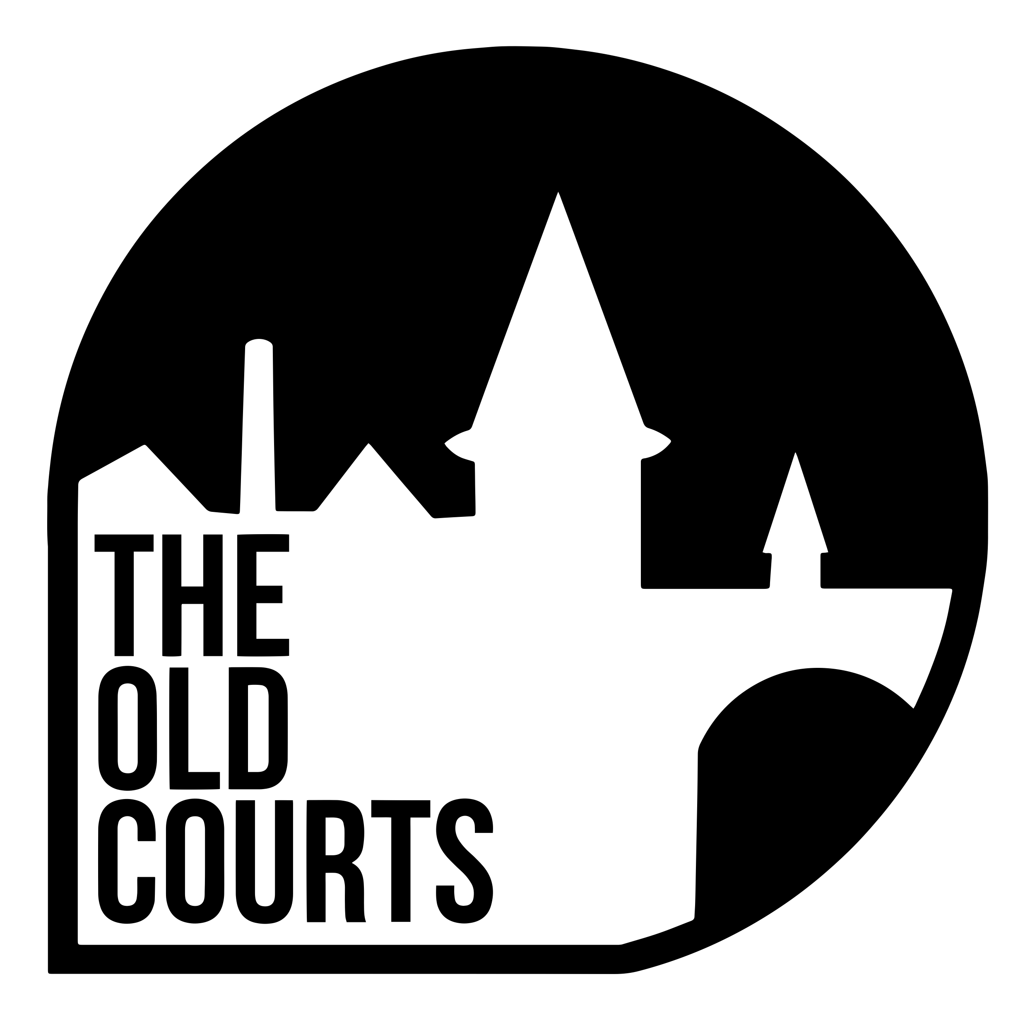

**Community Response Officer**

**Applicant Information Pack**

Contents

Introduction / How to Apply 2

About the Old Courts 3

Our Artistic Vision 3

What we do 4

Working at the Old Courts 5

The Role 6

Terms & Conditions 8

**06/01/2022**

# Introduction / How to Apply

Thank you for your interest in the role of **Community Response Officer** at Arts at the Mill CIC T/A The Old Courts. You will find information about the role and the person specification in the following pages. Before you apply, please read the information included here.

Please use the online application form to apply. A link to the online application form can be found on the [Jobs](https://www.theoldcourts.com/get-involved/jobs/) page of our website. You will need to upload your CV and a covering letter as part of the application.

All applications must be submitted by **Midday on Monday 24th January.** Successful shortlisted applicants will be invited to attend an interview on **Thursday 27th or Friday 28th January 2022**. We can provide a BSL interpreter if required.

If you would like further information, support with access requirements or an informal chat about the post please contact us by email at **jessr@theoldcourts.com**

We look forward to receiving your application.

People Team

Arts at the Mill CIC

# About the Old Courts

The Old Courts is all about changing perceptions. Our mission is to create, engage and inspire by supporting ideas and hard work, providing cultural opportunities, and investing in Wigan and its people.

Wigan is a place where world-class culture thrives.

# Our Artistic Vision

We understand the incredible importance of the arts – not simply for entertainment, but as the fundamental threads in the fabric of everyday life.

The arts should not be exclusive to the well-travelled nor a social tool for privileged circles. The arts are what bond communities and bridge differences with the only true global language, expression.

At The Old Courts, our work is designed to introduce the arts into the lives of the people of Wigan and beyond and to enhance the experience of those who are engaged.

We are driven to CREATE a vibrant, supportive, risk-taking and strategic environment for artists to ENGAGE new and existing audiences and disconnected communities who we will help to INSPIRE change with unrivalled ambition.

# What we do

**Artist Development**

We are fully committed to using our resource as a tool to further the progress of artists. Since first opening our doors we have played a part in the development of artists in many different ways. We have encountered raw talent from individuals seeking opportunity with little or no knowledge of how to find it and we have been approached by established performers who required support in networking or bid-writing. Whatever the ask, whatever the experience and whatever the artist is trying to achieve, we take pride in our ability to unlock potential and play a key role in development. The future of the arts is being forged as we speak. For arts and culture to play an increasingly important role in everyday life, time, experience, knowledge and dedication will always be needed from organisations like ours and we will continue to provide it.

**Producing**

We have a strong track-record in producing work for artists. A combination of in-house talent, facility and our wider network across The UK allows us to develop embryonic projects into touring, sustainable work. We understand the distance that can exist between a brilliant script and the stage but our ability to aid and structure the research, development and production of work allows work to be made entirely on site.

**Community Work**

Our surroundings play a fundamental role in everything we do. We are very proud to be from Wigan and based in Wigan and we appreciate how our organisation has been embraced by those who we live and work amongst. As such, we get great satisfaction from the many community projects we run. We have a community programme filled with meet-ups, social opportunities, upskilling, entertainment and more. The Old Courts is a place where anyone is welcome and it is fair to say that what we do is of significant value to a host of local groups and individuals

**Co-Creation**

We are developing several co-created projects which will bring artists to Wigan to make work with talent from our borough. One such project is ‘Moving Roots’ which involves theatre producers from partner organisations from around The UK, including London, Cardiff and Peterborough. As a member of this consortium and working with a theatre maker from Manchester, we recently created ‘Rent Party’, a show right here in Wigan created with local talent to provide a platform for both performers in the town and the culture of the town itself.

**Live Events**

Since day one, a significant part of what we do centres around live events. Gigs, dance shows, theatre shows, exhibitions, film screenings, sector conferences, audience events and seminars provide artists and the public with the maximum number of entry points to the arts.

# Working at the Old Courts

The Old Courts main office space is based inside the Former County Court offices on Crawford Street, Wigan Town Centre. We have a vibrant mix of individual offices and open plan co-working space with a selection of accessible meeting spaces.

The role will involve regular meetings, communicating via phone/video, email and in person and using a computer for several hours across the day. Some evening and weekend working may be required as part of this role. Attending performances, events and being part of the creative life of the organisation is part of everyone’s role at the Old Courts.

The Old Courts is a busy organisation and has around 60 members of staff. Usual office hours are 10am-6pm and we offer flexible working where possible. **We welcome discussing flexibility at interview.**

# The Role

**Responsible to: Head of Development**

**Responsible for: No line management responsibilities**

**Main Roles and Responsibilities include the below and carrying out any additional responsibilities as required by your line manager or by the leadership team of Arts at the Mill CIC.**

The Community Response Officer will manage the day-to-day administration of a growing community effort to match volunteers with isolated residents in Wigan borough. Born out of the Covid-19 pandemic, the community response is a service which creates opportunities for local people to connect via phone conversations with residents who are experiencing isolation and a range of concerns due to the impact of the pandemic. To date, the service has completed 1,027 help requests, 2,350 welfare calls and delivered 740 food parcels.

The Community Response Officer is responsible for the management of the community response service. The role will suit someone with great organisational and interpersonal skills, compassion, and the ability to efficiently handle desk-based administrative tasks and systems. You will be the main point of contact for volunteers and service users, and so being a good listener who is professional and informative is key to the success of this role.

Externally, develop and main relationships with key partners (for example: community organisations, Local Authority) to ensure the service well connected at a local level and is of the most benefit to volunteers and Wigan borough residents. Overall, the role requires a person who is a confident communicator who excels at keeping key stakeholders up to date with progress and opportunities and can easily work with others to achieve agreed outcomes.

Proven experience of working in an administrative or coordination role within community projects, volunteer programmes, and/or an understanding of the issues faced by isolated residents will be an advantage.

We welcome someone bringing fresh energy, insight, and new skills & experience into our workplace. We are actively seeking diversity of experience, and whoever you are, we would love to hear from you! We would love to receive applications from people who identify as working class, LGBTQIA+, deaf or disabled, care-experienced, young carers, young people of South, East and South East Asian heritage, African or Caribbean heritage, Gypsy, Roma or Irish Traveller heritage or Latinx heritage.

**Outlined below are several standard duties that this job role entails:**

1. To manage, improve grow a supportive service

* Use our systems to track & update on the progress of the community response (update call logs, keep schedules up to date)
* To respond to issues flagged by volunteers and beneficiaries promptly and professionally, and escalate accordingly
* To update and manage the community response risk register
* To act as the main point of contact for community response partners and funders (such as Local Authority), providing updates and reports when needed
* Develop and maintain strong relationships with local partners, build links and opportunities for improved signposting for volunteers and beneficiaries
* Lead on planning both internal and external meetings for the community response; arranging agendas, logistics, guests, and access provisions incl. recording and streaming where appropriate
* Work with the wider Development team to establish what success looks like and ensure this is effectively measured, monitored, and reported.
* Support the Project Director and/or Directors with the development of external facing documents and presentation about the community response when necessary
* Contribute towards bi-monthly and annual reports

1. Support volunteers and service users

* Recruit, onboard, train and supervise volunteers
* Recruit a diverse range of volunteers, including those with lived experience
* Maintain clear and regular communication with volunteers
* Ensure volunteers maintain accurate and timely records of their engagement with the service
* Ensure volunteers feel supported to build long-term relationships with residents (e.g. through the development of shared resources and activities)
* Delegate and/or cover phone calls when volunteers are absent
* Organise regular check-ins with community response service users to ensure they are happy with the service and can continually feed into the development of the service
* Work with external partners and Local Authority to support beneficiaries as they are signposted into the service
* Lead on opportunities to boost volunteer and service user engagement and morale, such as in-person/zoom meetups and events

**Person Specification**

|  |  |  |
| --- | --- | --- |
| Skills & Abilities | Desirable | Essential |
| Experience of working within the voluntary sectors, community projects, or managing a volunteering programme |  | X |
| Able to maintain effective working relationships with a wide variety of people and organisations |  | X |
| Excellent written and verbal communication skills |  | X |
| Attention to detail |  | X |
| Understanding and commitment to equal opportunities and an ability to relate to people across the community |  | X |
| Good IT skills with a good working knowledge of Microsoft Office Word and Excel, and ability to learn new project management software |  | X |
| Self-motivated and able to work unsupervised with good administration, organisational, and time management skills |  | X |
| Experience of and a commitment to robust safeguarding |  | X |
| Demonstrable success in delivery of services under partnership arrangements and/or in working in a similar way with Local Authorities | X |  |
| Experience of working with others to achieve agreed outcomes (multi-agency approach) | X |  |
| Good working knowledge of Wigan borough, its VCSE landscape and local community need | X |  |
| Ability to work flexibly according to the requirements of the post | X |  |
| Prepared to travel when required | X |  |
| Values |  |  |
| Compassion and care for social issues and an understanding of the organisation’s mission |  | X |
| A commitment to working with others to achieve agreed outcomes. |  | X |

# 

# Terms & Conditions

This post is subject to Disclosure and Barring Service Enhanced checks.

**Salary: £24,000** gross per annum, depending on experience

**Hours: 37.5** hours per week, excluding a daily one-hour lunch break.

This role is 5 days a week Monday-Friday; usual office hours are 10am-6pm. We offer flexible working where possible.

Occasional evening and weekend work may be required. All staff at The Old Courts are expected to attend performances and be a part of the artistic life of the organisation.

**Overtime:** No overtime payments.

**Annual Leave:** 25 Days + Statutory Holidays

**Probation period:** **6 months**, with a 3 month review

**Notice period:** **1 Month**

**Contract Period: The post is initially offered on a 12-month fixed term basis in line with our current community response funding agreement. Opportunities for the continuation of the role will be reassessed and may be offered to the successful candidate, subject to any 2022-2023 funding and its terms and conditions.**

**Workplace Pension**

**Scheme:**  Arts at the Mill CIC pension scheme is provided by True Potential

**Staff Benefits** Complimentary tickets for performances at Old Courts (subject to availability and staff ticket policy)

Cycle to Work Scheme

Discount on Drinks and Meals in café and Bars (subject to discount policy)