

**Artist Applications to ROOM:**

**Artist Residency and development space at The Old Courts supported by TERM art classes**

The Old Courts is offering a dynamic residency space opportunity supported by TERM Art Classes, for local artists or those with links to Wigan borough to create, experiment, and develop their work. We invite artists from all disciplines to apply, with a focus on those interested in exploring new ideas, engaging with the community, and pushing creative boundaries. This is a pilot scheme to see how The Old Courts can help support visual artists so feedback after the residency will help future programmes.

**Programme Overview:**

* Artists can apply for 2 weeks minimum - 3 months maximum residency without cost or fees.
* Rolling residency programme beginning 21st July for first cohort and finishing 12th Dec.
* A maximum of four Artists in Residence will be accommodated at any given time.
* Artists must be committed to using the space consistently throughout the week, whether during the day or evenings to ensure consistent progress on their project.
* Access to studio: Monday – Wednesday 8am – 9pm, Thursday - Saturday 8am – 12am
* Artists are encouraged to share their progress with the public through final exhibitions, talks, invites to open studio or informal studio visits.
* The residency is geared towards visual artists looking to develop new work with no restrictions on the medium or discipline.
* The programme encourages interaction with fellow artists in residence, fostering a creative community that supports networking and idea exchange.
* Artists are expected to work safely and adhere to the health and safety codes provided.
* Opportunity for artist development through The Old Courts, outline any of your needs such as; marketing, funding support etc and we can see what could be supported

**Space and Resources:**

The Old Courts will provide a studio space which includes the following resources:

* Natural and artificial lighting.
* Chairs or stools for working.
* Ample work surfaces and tables.
* Power outlets.
* Sink / water source for cleaning materials.
* Shelves for storing materials and works.
* Ventilation: Windows. Space in the back courtyard can be used for spray paint or other noxious materials.
* Wi-Fi access for research or communication needs.
* Wall space for displaying or creating hanging artworks.
* Drying racks for artworks.
* Individual workstations for each resident.
* Access to bins for recycling and general waste.
* Safety Equipment: First aid kits, fire extinguishers, and emergency protocols.
* Access to Toilets.
* Key Access for flexibility (see allocated access times)
* Log Book to check-in and check-out for security and safety.
* A safety induction upon arrival to ensure proper use of the space.
* Break-out communal area that can be used for exhibiting
* 2 Rooms: Room 1 measures 5200mm x 4200mm. Room 2 measures 7500mm x 3500mm. Artists will each be allocated a space.
* Please note no naked flames to be used in the studios.
* Also note that spaces are not private and are technically open to public during opening hours so do not leave valuables on site.

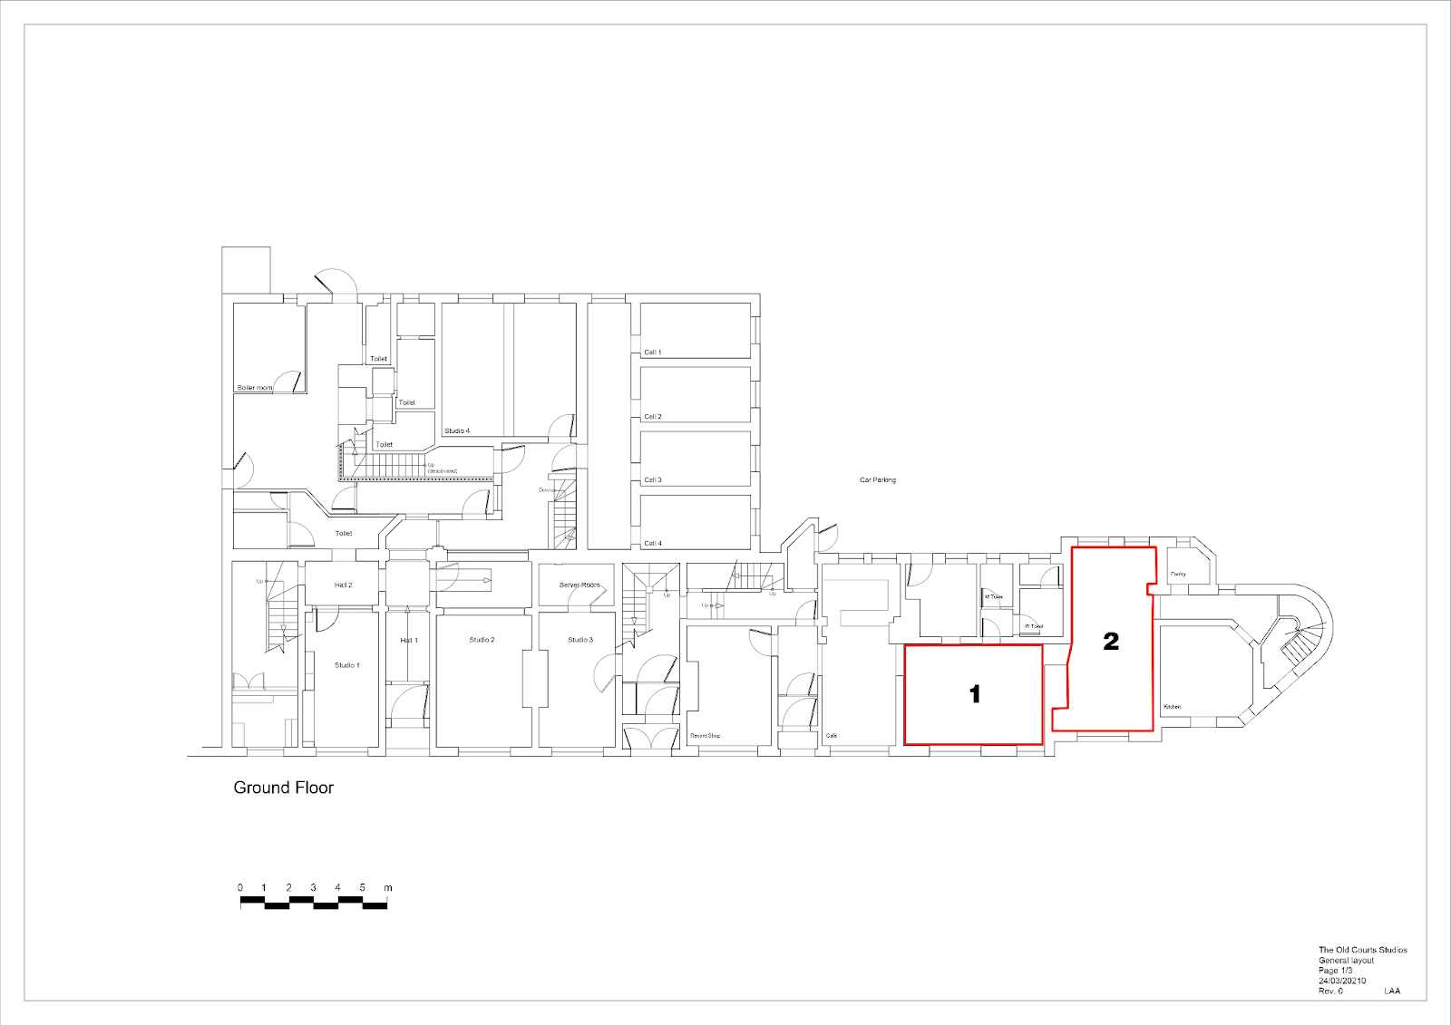

**Management and Selection Process:**

* The selection Panel is made up of local artists Klaire Doyle and Anna FC Smith as TERM art classes.
* The selection will be based on the originality, creativity, and quality of the proposed projects that are forward-thinking, experimental proposals that show the greatest need for the space.
* The programme aims to support a wide range of creative voices and mediums.
* Day to day management of the space and facilitation of public facing showcases will be run by The Old Courts

**Submit your answers via the google doc or email** to [termartclass@gmail.com](mailto:termartclass@gmail.com) subject: ROOM residency application

Proposals are accepted on a rolling basis but earlier applications will be more likely to guarantee a studio. We look forward to hearing from you!